|  |
| --- |
| **ABDULLAH TAHIR 20151160**  11-20-2015  Mentor Professors  Prof. Jae Hun Seol, Prof. Hyo Sung Ahn |
| School of Mechatronics  Gwangju Institute of Science and Technology |

|  |
| --- |
| Mechatronics Project |
| Self-Generation Temperature Bicycle |
| Individual Report |

Table of Contents

1. Objective 1

2. Significance 1

3. Background and Patent 2

4. Hardware Design 3

4.1. Required Electrical Components 3

4.2. Circuit Prototyping and Hardware Testing 4

4.3. Finalizing Circuit 8

5. Software Design 9

6. My Contribution 10

7. References 11

**List of Figures**

Figure 1 Left figure shows bicycle in summer, Right figure shows bicycle in winter 1

Figure 2 Patent Information 2

Figure 3 Left: LCD interfaced with Arduino, Right: 2N222 PNP transistor for switching power 4

Figure 4 Push button configurations 5

Figure 5 Bouncing on press and release of push button 5

Figure 6 Peltier 5

Figure 7 Ni-Chrome wire coil 6

Figure 8 Left: Commercially available high power switching circuit, Right: IRF540 high power MOSFET transistor 6

Figure 9 Left: IRF540 interfaced with Arduino, Right: IRF540 Characteristic curve 6

Figure 10 Multiple power sources, dynamo and solar cell 7

Figure 11 Flow diagram of power 7

Figure 12 Overall interconnection of different electrical components 8

Figure 13 Proteus Simulation 8

Figure 14 Software flow diagram 9

Figure 15 My contribution 10

## Objective

Objective of this term project is to build a bicycle quite capable of maintaining its temperature as per requirement of rider by generating enough electric power to drive electrical components.

## Significance

Millions of people around the globe use bicycle as an economic way of travelling. Even bicycling is hobby to thousands of them. To respond to the growing interest in people of cycling, destinations like Oregon have been positioning themselves as cycle-friendly cities, quadrupling its state bike routes, while more travel outfits are creating cross-country bike tours around the world. In Europe, an initiative is currently underway to develop a network of cycling routes that would connect the whole continent by 2020.

Or if we take the example of GIST, every student possesses a bicycle. Even some professors ride bicycles. In order to make the bicycle ride comfortable for people, researchers and hobbyists have been trying to improve the efficiency of mechanical mechanism. Some are successful to attach a small motor so that when rider is tired, he/she could turn on the motor and enjoy a stress less ride. Bicycle dynamo are commercially available for lighting up the headlight.

In our case, we try to help riders in different scenario. Thermodynamics is the phenomenon of nature. Heat travels from high temperature gradient to low temperature gradient. Same can be observed in bicycles. During summer body of bicycles get so hot that rider feels uncomfortable to tough the handle and sit on the saddle. Same feeling is experienced by rider during winter when saddle and bicycle temperature are too cold as can be seen in Figure 1. I have observed people riding bicycle in uncomfortable situation. People endure this situation and they just ride as they don’t have any alternative solution for their problems.

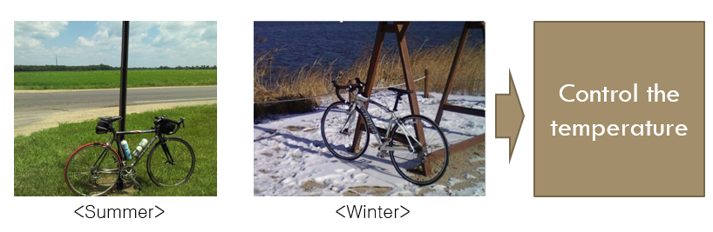

Figure Left figure shows bicycle in summer, Right figure shows bicycle in winter

Until now significant attention has not been paid by researchers to address this issue. Recognizing the need to tackle this problem, our team came up with an idea to build a bicycle which uses renewable energy resources to produce electric power and drives the electric circuits which in turn maintains the temperature as adjusted by the rider.

## Background and Patent

A patent with somehow similar work was found. Patent information is as under:

Title: Self-development by Hot/Cold Thermal Bike

Application number: 10-2012-0150282

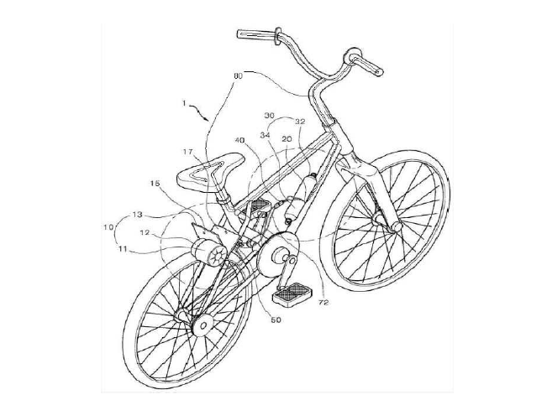Content of patent: by using wheel’s rotation, generator produces electric power. This electric power is used for running the peltier components. Peltier component converts electric power to thermal power and thus generates heating at handle and saddle.

Figure 2 Patent Information

Figure 2 describes the concept of the patent. At first, patent doesn’t show any information about the control. Temperature control is key property of the project. Secondly there is no user interface at all. Thirdly patent does not use rechargeable batteries and other renewable energy sources. Current patent limits the operation of system in a sense that they are relying purely on the power generated by rotating dynamo. Hence during stop condition there is no power and in turn no operation of heating and cooling.

Thus I can say that our system is different from already existing system in following areas:

* User Interface: Our system allows user to enter the preset temperature. There are push buttons for interactions and visual feedback through LCD.
* We are using rechargeable batteries.
* Our system doesn’t rely only on the generator for producing electrical power. We are using solar cell as well.
* As peltier has very low efficiency (around 5%) so we are using peltiers only for cooling. For heating we are using ni-chrome wires which have efficiency of the order of approx. 80%.

## Hardware Design

This section explains about the hardware components.

Analog and digital circuit design are crucial parts to the hardware development and engineering process. Once we have the idea that what we are going to build to the product the very next step is to think about the electronics involved. *Temperature is controlled only for handle and saddle.*

In order to make to make any electric circuit to be working perfectly, selection of components depends upon the power of electrical components. Just like we cannot run a 18V laptop by the series connection of 12x1.5AA batteries. Since series combination of batteries is not appropriate for providing adequate amount of electric power to the laptop.

For hardware design I can summarize the how we finally made the working hardware with following steps

## Required Electrical Components

We had to make our idea different from already existing patent. So we have to do all of the things that I mentioned in Background and Patent section.

**User Interface**

User interface of our system involves a 20x4 LCD and push buttons. Push buttons used for user to input the temperature values and control the start/stop actions of heating/cooling. And visual feedback to user’s actions is provided by 20x4 LCD. LCD displays the current temperature, preset temperature as required by user and information about whether or not the heating/cooling action is On.

**Peltiers and Heating Coils**

For temperature control, there is need to both heating and cooling. Heating during winter and cooling during summer. Although peltier can do this job (both heating and cooling by merely reversing the direction of current flow) but its efficiency is very low of the order of only 5%. But currently as there is no commercial product available as an alternative so we decided to use peltier for cooling and using ni-chrome wire as heating coil for heating which has comparatively quite excellent efficiency around 80%.

**Control Circuitry**

In order to read the user inputs from push buttons, display the corresponding actions on the LCD, to control the peltiers, turn on and off the cooling fan, turn on and off the LCD back light and maintaining the temperature there is a need to use some microcontroller or FPGA or DSP or microprocessor. We selected Arduino for this purpose.

**Temperature Sensor**

And of course to control the temperature Arduino has to do data acquisition from temperature sensor. For our job we selected LM35 temperature sensor. The basic reason for its selection is that it has linear relationship between voltage and temperature with range of -50oC to +150oC.

**Energy Sources**

To power up the whole system we require power sources. In our case we cannot rely merely on the dynamo generated power. Although dynamo generates 6W of power at the bicycle speed of 10kmph but still it is not enough. Therefore we decided to use solar cell as another mean of power. Not only this, we also attached a rechargeable battery. This battery is primarily used for powering the whole system. Bicycle dynamo and solar cells output is superimposed making a bus bar and this bus bar is then fed to the battery.

**High Power Circuit Design**

As I already explained that power matching is important for designing of electrical circuits. Different peltiers require different current ranging from 4A to 60A. Since microcontroller can supply current around 500mA so there is a need to make high power electronics components for switching high current when commanded by Arduino. Currently we are using IRF540 MOSFET transistors which can be found in UPS and other circuits, continuous current that this transistor can bear is 22A.

## Circuit Prototyping and Hardware Testing

Until now we know very well that what we are going to do and which components we have to attach. Let us now check the working principal, pin configuration, interfacing with Arduino of each component and test the prototype circuit on the bread board one by one. Initially tested each module on bread board and then made the actual circuit.

**Liquid Crystal Display**

We are using simple 20 character by 4 line display. It utilizes the extremely common HD44780 parallel interface chipset. Only 11 wires are needed to be connected with general I/O pins of Arduino. It also includes LED backlight. But in order to save the battery power I am not turning on the backlight all the time. Backlight is On only when user tries to set the temperature or turn on/off the heating/cooling operation.

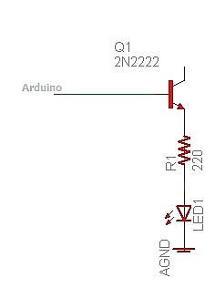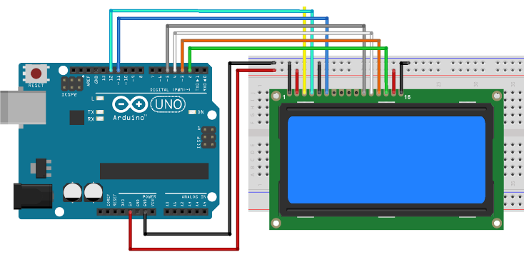

Figure 3 Left: LCD interfaced with Arduino, Right: 2N222 PNP transistor for switching power

And for controlling the LCD back light, I used 2N2222 PNP transistor to switch power for LED as shown in Figure 3. First we tried all this circuit prototype on bread board.

**Push Buttons**

In industrial and commercial applications, push buttons can be connected with microcontrollers to control some process and to get the input by the user. Push button simply make the circuit when the button is pressed and break the circuit path when it is released.

There are two configuration for push button to be attached with microcontroller named as pull up and pull down as explained in Figure 4. I used it in pull up configuration.

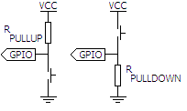

Figure Push button configurations

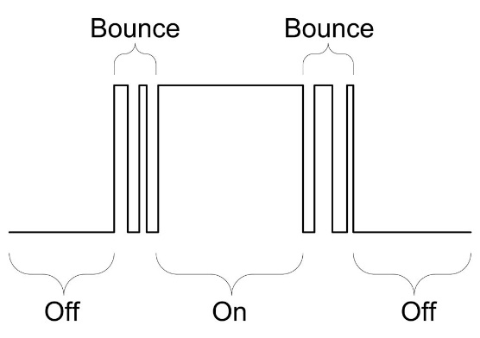

Figure Bouncing on press and release of push button

When we are using pushbuttons we have to take into account the effect of bouncing as mentioned in Figure 5. Buttons have spring inside them, so when user presses the button due to mechanical mechanism there are oscillations, hence only for one switch press there are multiple signals being generated. Hence I used de-bouncing mechanism to eliminate this effect and Arduino reads only one input for one press.

So we made this circuit on bread board tested it before making the actual circuit.

**Peltier**

Peltier is the thermoelectric component. The **thermoelectric effect** is the direct conversion of temperature differences to electric voltage and vice versa. A thermoelectric device creates voltage when there is a different temperature on each side. Conversely, when a voltage is applied to it, it creates a temperature difference. At the atomic scale, an applied temperature gradient causes charge carriers in the material to diffuse from the hot side to the cold side. Thermoelectric device has two operating schemes:

* Seebeck effect: Conversion from temperature to current

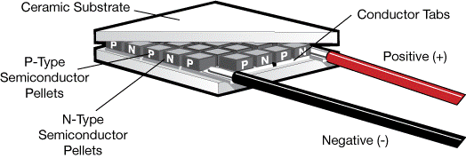

Figure Peltier

* Peltier effect: Conversion from current to temperature

We are using peltier effect. Initially we tested the peltier by connecting it with power supply and then designed the circuit to power it. Circuit is explained later.

**Heating Coil**

Since peltier has very low efficiency approx. 5% so we decided to use ni-chrome wire for heating. Peltier is very compact and of small size which suits us best for cooling but for heating we have another option of using ni-chrome wires which have fairly good efficiency of the order of 80%. This is also being used in many commercial products, an electric heater is one of those examples.

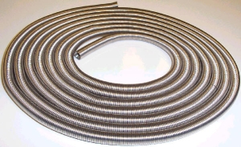

Figure Ni-Chrome wire coil

The **Joule's law** states that the quantity of heat produced in a resistor is directly proportional to: (i) the square of current for a given resistance, (ii) the resistance for a given current, and (iii) the time for which the current flows through the resistor, i.e., H = I2Rt.

**Power Amplifier**

As Arduino datasheet tells that maximum output current from digital I/O is 500mA so it is sure that we cannot connect peltier and heating coil directly with the pin. So there is the need to use some power driver between them. High power switching circuits are commercially available just like motor drivers but they are expensive. One of our major concerns is low cost. So instead of purchasing high cost commercially available power amplifiers we designed our own circuit for switching.

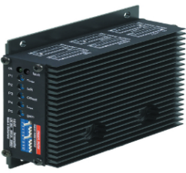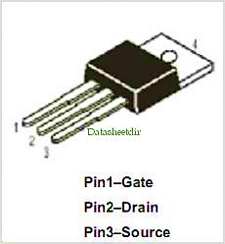

Figure Left: Commercially available high power switching circuit, Right: IRF540 high power MOSFET transistor

For this purpose we used IRF540 MOSFET transistor capable of bearing continuous current of 22A. This device is widely used in industry and can also be been in Uninterrupted Power Supplies. For different values of PID controller O/P for temperature I used analog pin of Arduino to drive it at different currents thus maintaining the temperature.

In Figure 9 I showed the schematic to attach peltier with IRF540 which is in turn connected with Arduino microcontroller. One analog pin of Arduino is used to control one peltier. On the right there is shown the characteristic curve of IRF540, it is evident that by the change of VGS Io changes. The same phenomenon I have utilized for controlling the temperature through PID control loop.

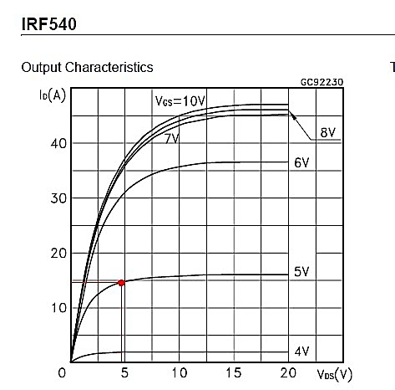

Figure Left: IRF540 interfaced with Arduino, Right: IRF540 Characteristic curve

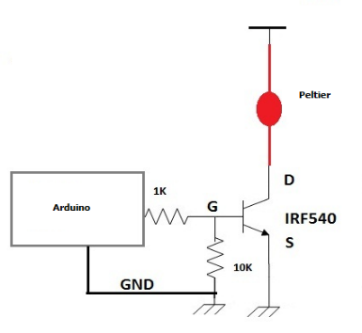

Control circuitry for heating wires is same as that of peltiers.

**Dynamo and Solar Cell**

For high power demand of peltiers and heating wires is necessary to accumulate as much power as possible. For this purpose we are using four dynamo (generators) and two solar cells with power rating of 6W each.

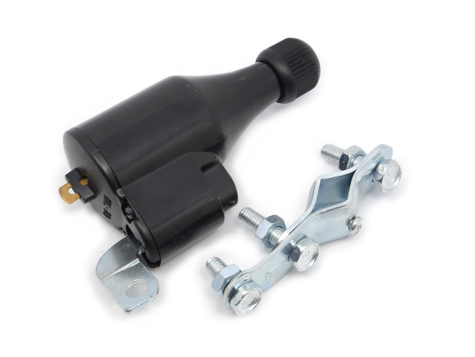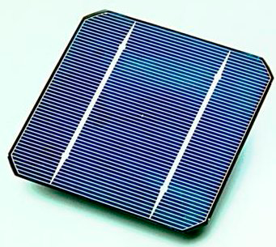

Figure Multiple power sources, dynamo and solar cell

Dynamos are commercially available and mainly used for powering up the bicycle headlight. During the testing we came to know that O/P of dynamo is not DC rather it is AC. Therefore we decided to use full wave bridge rectifier to convert AC in to DC and then combined DC voltages from dynamos with DC voltages from solar cells. This made a small bus bar. I connected this bus bar with battery recharging circuits and attached rechargeable batteries with these battery recharging circuits which take care of over and under voltage protection. I also mention that I used one line diode in series with solar cell to protect from current back flow.

Solar Cell O/P

Dynamo O/P

Full Wave Bridge Rectifier

Battery Recharging Circuit

Diode

Rechargeable Battery

AC

DC Bus Bar

DC

Figure Flow diagram of power

## Finalizing Circuit

In the previous step we checked all of the hardware components on the breadboard. Next step is to make the wired circuit. We also have to take in to account the bicycle structure and mounting the circuit on the correct place is another job. The designed circuit should be able to mount easily and at that mounting place it should not restrict degrees of freedom of rider.

With all these constraints we decided the spot beneath the bicycle handle would be an appropriate place for Arduino controller. User interface should be attached to another circuit which is mounted on the handle. This user interface comprising of LCD and push buttons will be connected with wires. Long cables will connect peltiers which are at handle and saddle with microcontroller.

In the following figure the overall interconnection between different components has been explained.

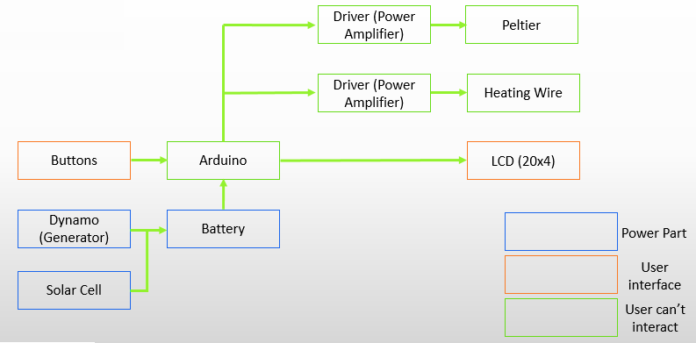

Figure Overall interconnection of different electrical components

Finally we decided the spatial location of each electric component on the circuit board and soldered each component one by one. And tested it once again before mounting it on to the bicycle. I used Proteus software to do the simulation of electrical components before using.

Figure Proteus Simulation

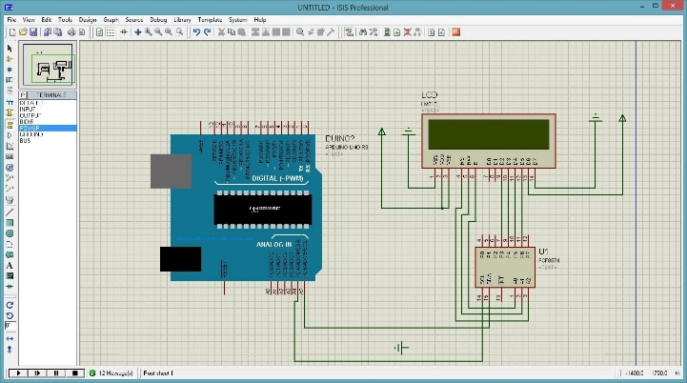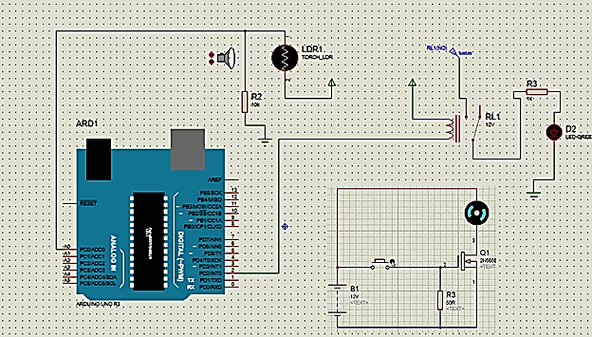

## Software Design

In the software we are intended to control the hardware part. Brain of whole system is Arduino. I feel it is not necessary to write the code and explain it, instead it is good approach to show all by flow diagram as in Figure 14.

Figure Software flow diagram

Turn ON cooling

Display data on LCD

Yes

No

No

Yes

Yes

User preset Temp.

Initialize Variables

Display data on LCD

Temp. Acquisition

Display on LCD

Display data on LCD

Is Temp. difference ≠ 0

Is Current Temp. High

Turn ON heating

Display data on LCD

## My Contribution

We divided our team in three sub-groups. One working on hardware, one working on software and one working on mechanical fabrication works. Initially I was in hardware team to build up the hardware circuit so I mentioned hardware components in detail in Hardware Design section, however as my undergraduate majors is mechatronics so this project is of my very interest. Hence I involved myself in other teams so assist them as much as I can.

Figure 15 My contribution

Figure 15 explains my dedication to this project, but I would like to figure out some points

* I made the 80% circuit for the project.
* In addition, I did the programming for controlling peltiers and heating coils and implemented de-bouncing algorithm for push buttons.
* I not only gave the idea but also made our own high power switching circuits since I already had experience of developing high current H-bridge circuits. Thus making the project cost effective.
* Instead of conventional On/Off control, I proposed using PID control loop with variable gains (Kp, Ki and Kd), large gains at start up, because without effecting cooling system heat from hot side of peltiers also heats up the cooling side as well, and this way it doesn’t serve the purpose of cooling.
* To save battery power I suggested to turn on LCD back light only when user presses some button.
* During experiments two of our peltiers burnt. I figured out that a little change in the Gate voltage changes current a lot so during PID loop it is necessary to maintain a level of maximum current to save battery power and prevent peltier from burning as shown in Figure 9 Right.

## References

[1] H. Saghlatoon, M. Soleimani, S. Moghimi, and M. Talebi, “An experimental investigation about the heat transfer phenomenon in human teeth,” *20th Iran. Conf. Electr. Eng.*, pp. 1598–1601, 2012.

[2] a. M. N. Lima, G. S. Deep, L. a. L. de Almeida, H. Neff, and M. Fontana, “A gain-scheduling PID-like controller for Peltier-based thermal hysteresis characterization platform,” *IMTC 2001. Proc. 18th IEEE Instrum. Meas. Technol. Conf. Rediscovering Meas. Age Informatics (Cat. No.01CH 37188)*, vol. 2, pp. 919–924, 2001.

[3] S. Epure and R. Solea, “Low Power Battery Charger with Solar Panel Input.”